Mohammad Fauzan P.D.
264107020159
TI – 1C / 19
Latihan 1
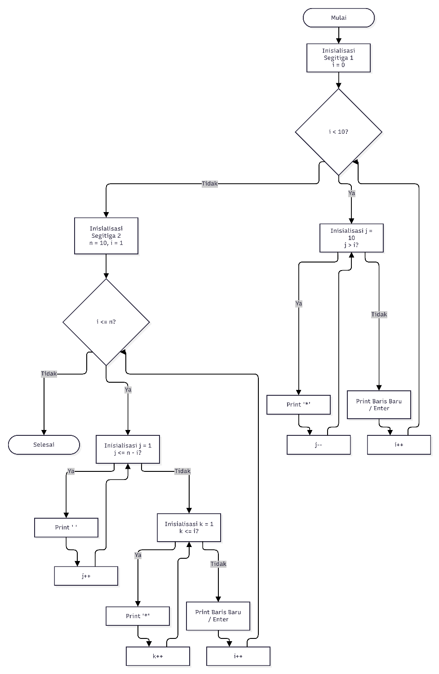

Latihan 2
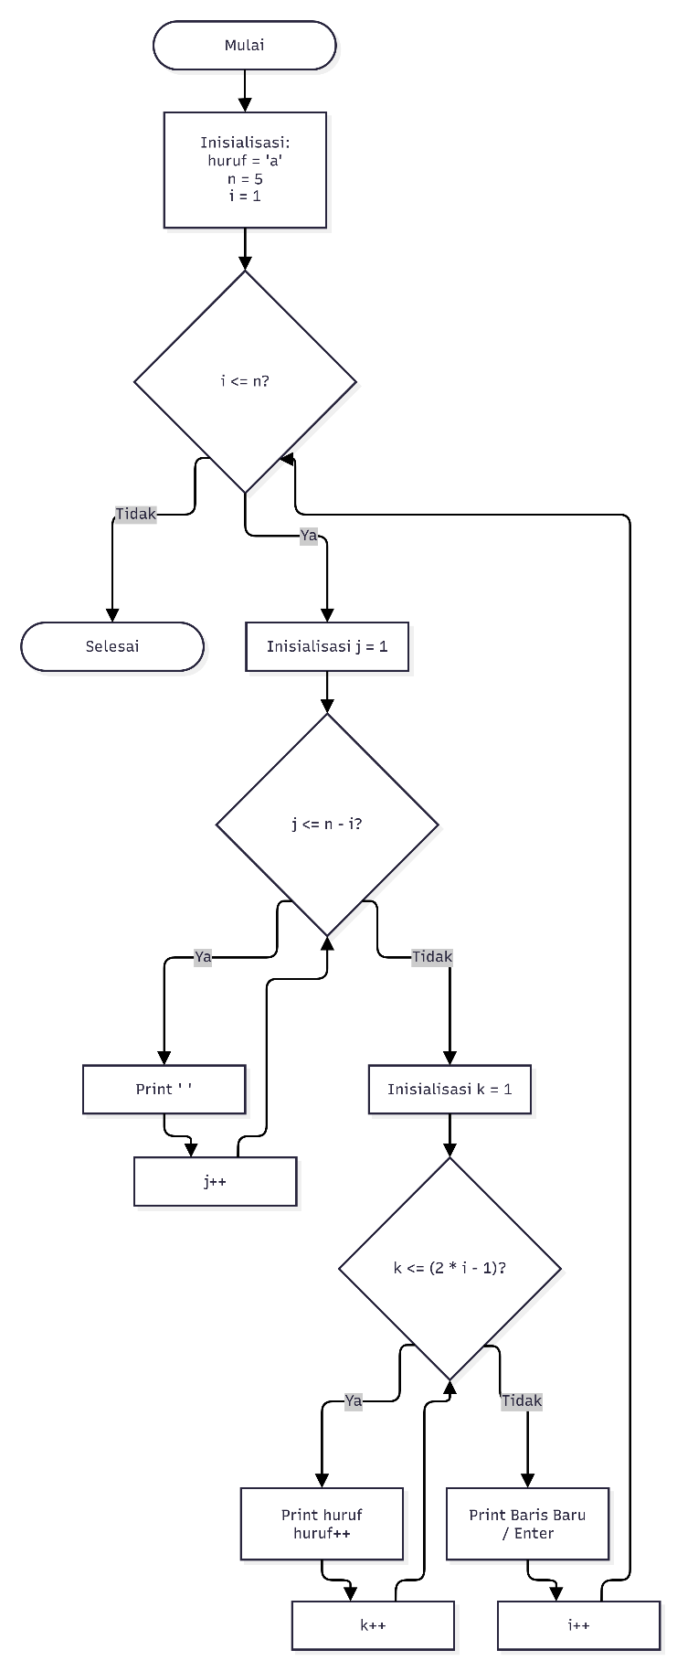

Latihan 3
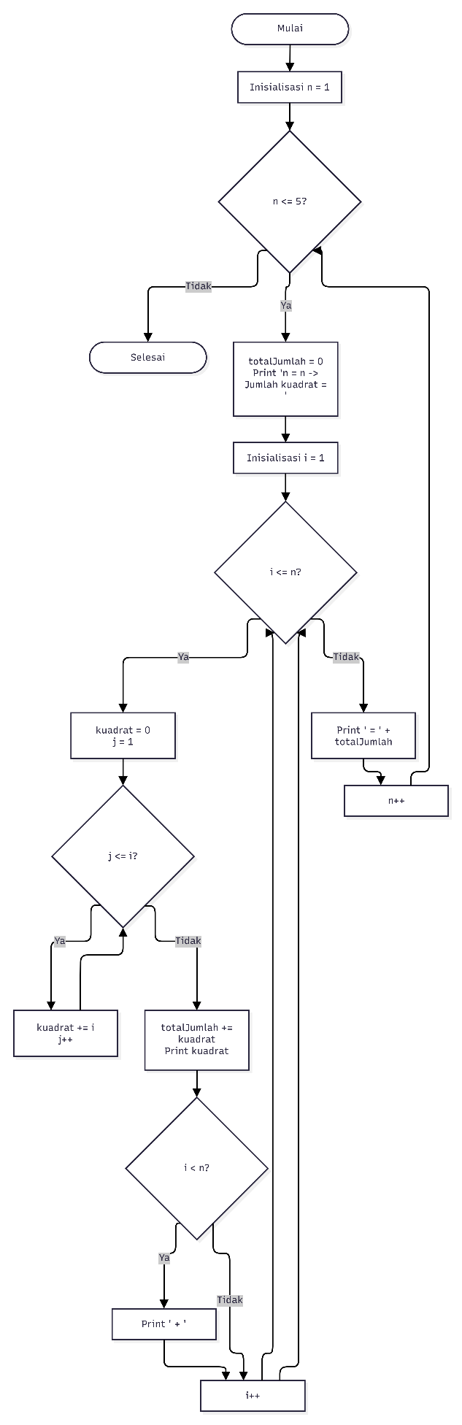

Latihan 4
